OFFICE
For Lease
Class A Office Space-82,475 SF

7340 W Memorial Avenue
Oklahoma City, OK. 73142
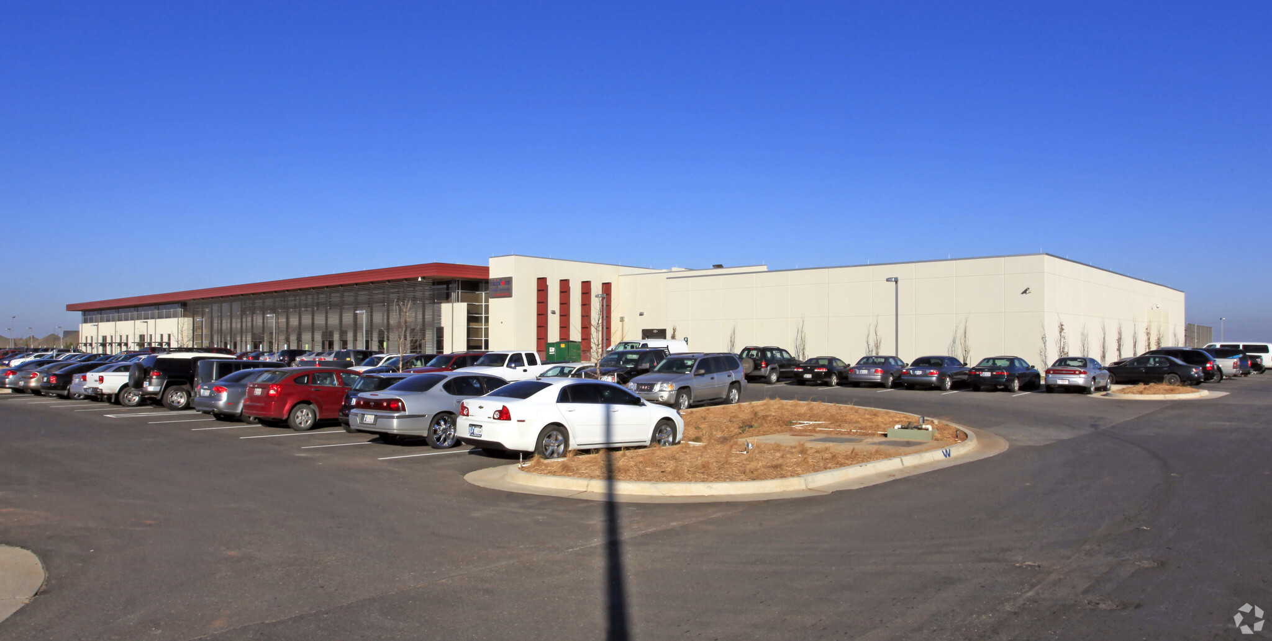

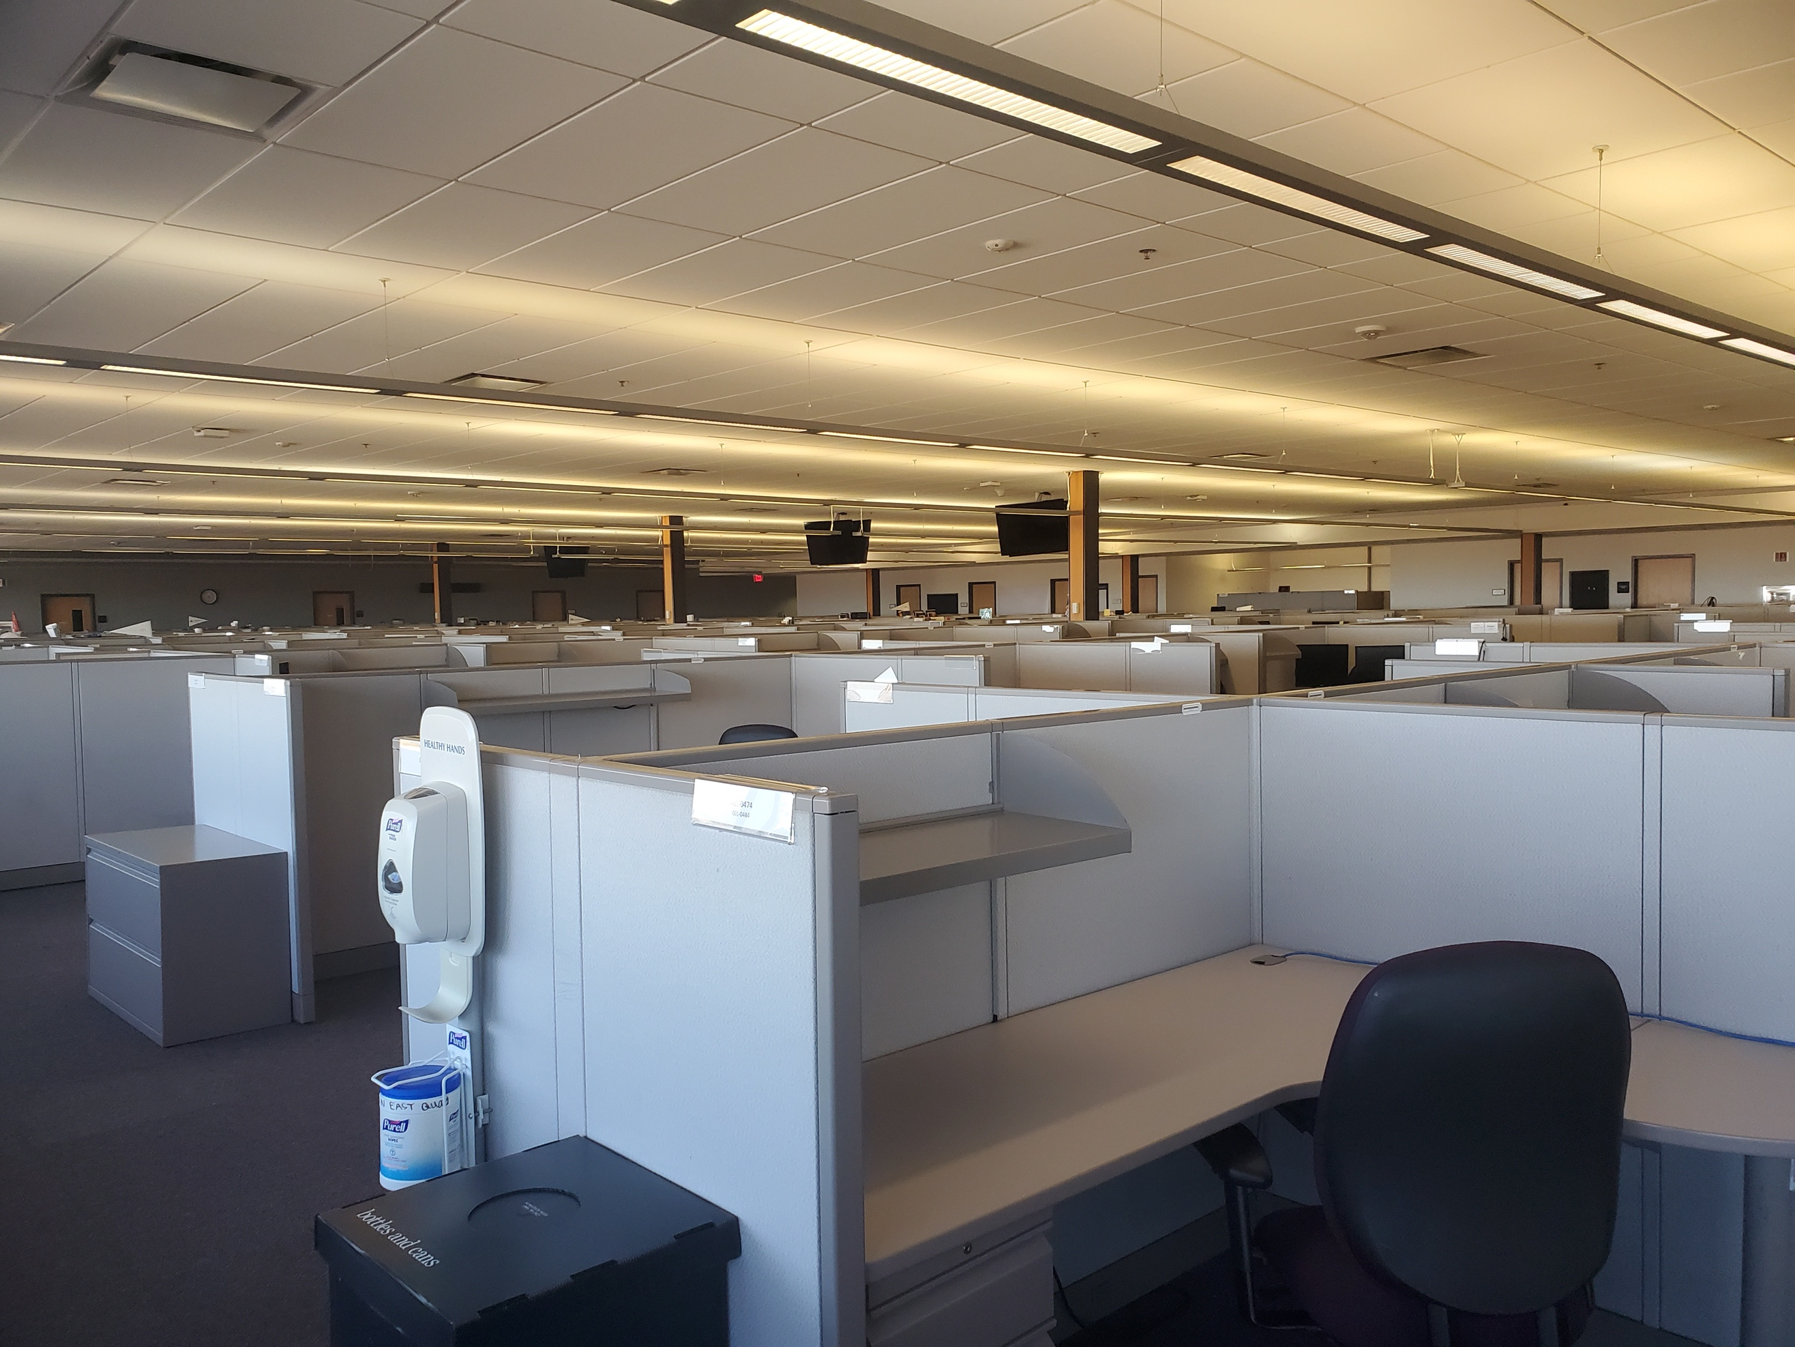

- 82,475rsf
- $20/sf FSG
- Excellent access and visibility from Kilpatrick Turnpike
- Over 950 workstations in place
- Abundant parking
- Dedicated air handlers
- Central UPS
- 2 IDF and 4 electrical rooms

- 4 mega-watt of back-up diesel generator power – in the process of installing a second utility feed
- 2 – 750 chiller/tower systems

P. SCOTT WIECZOREK

5030 N. May Avenue, #435, Oklahoma City, OK 73112 405.698.1150 (oﬃce) • 405.210.3894 (mobile)

scott@avenuecre.com • www.avenuecre.com

OFFICE For Lease

